**CHAPTER 1**

**INTRODUCTION**

Ludo, a beloved board game that has stood the test of time, emerges from ancient roots in India to captivate players worldwide with its universal appeal. The simplicity of Ludo's rules, combined with the excitement of chance, fosters an atmosphere of friendly competition and strategic thinking. Played by two to four participants, each with their colorful tokens, Ludo's objective is straightforward: navigate the game board and advance tokens to the central home column. The roll of the die adds an element of unpredictability, creating moments of suspense and anticipation, making each game session unique.

1.1 **Motivation**

The motivation behind the enduring popularity of Ludo lies in its ability to transcend generations and cultural boundaries. As a social game, Ludo brings people together, fostering shared moments of joy, laughter, and camaraderie. Its adaptability is evident in various regional variations and house rules, allowing for a personalized gaming experience. In the digital age, the motivation to digitize Ludo further stems from a desire to preserve its traditional charm while providing accessibility to a broader audience. The transition to digital platforms, including mobile apps and computer games, ensures that the timeless enjoyment of Ludo can persist in both classic and modern contexts, catering to diverse preferences and lifestyles.

Top of Form

1.2 **Background of problem**

The background of the problem typically revolves around the challenges and considerations involved in transitioning the traditional board game to a digital platform. While Ludo has successfully made this leap, certain issues and complexities arise in the process.

The main key challenge is to maintain the essence of Ludo's simplicity and accessibility in digital verse. The transition to a digital platform often involves user interfaces, controls and graphics that must be keenly designed to preserve the game's intuitive nature. Maintaining the right balance between modern design elements and the traditional charm of Ludo becomes crucial to ensure an engaging and enjoyable user experience.

Additionally, ensuring seamless multiplayer functionality, addressing network related issues, and maintaining game's integrity in the face of potential glitches are key considerations for developers in this digital evolution.

In summary, background of the problem in the digital adaptation of Ludo lies in finding solutions to maintain game's simplicity, preserving its social aspects, and addressing technical challenges to offer an authentic and enjoyable experience in the digital age.

1.3 **Current System and Issues**

1.3.1 **Concurrency Issues**:

* Ensure proper synchronization when dealing with multiple players and turns.
* Address race conditions that may arise during simultaneous dice rolls or piece movements.

1.3.2 **GUI Responsiveness**:

* Prevent the GUI from freezing during time-consuming tasks (e.g., complex animations).
* Consider using threads or timers to manage animations and updates.

1.3.3 **Error Handling**:

* Implement robust error handling to manage unexpected inputs or situations.
* Display appropriate messages to users when errors occur.

1.3.4 **Testing**:

* Conduct thorough testing of the game to identify and fix bugs.
* Test different scenarios, edge cases, and corner cases.

1.3.5 **Code Maintainability**:

* Write modular and well-documented code for easier maintenance.
* Consider using design patterns to enhance code structure.

1.3.6 **Scalability**:

* Plan for scalability if you intend to add features or extend the game later.
* Design the codebase to accommodate future enhancements.

1.4 **Functionality Issues**

1.4.1 **Game-play Mechanics**

* **Token Movement**: There may be issues with token movement, such as instances where the tokens might not move the set number of spaces on the dice.
* **Rule Enforcement**: The game might fail to accurately implement Ludo rules, leading to discrepancies.

1.4.2 **User Interactions**

* **Turn Handling**: The current system may not effectively manage turns or skips, resulting in players taking multiple consecutive turns or skips unintentionally.
* **User Interface Responsiveness**: Issues related to the response factor of the user interface may affect overall performance. Delayed in any movement can diminish the enjoyment of the game.

1.4.3 **Feature Inconsistencies**

* **Multiplayer Synchronization**: In multiplayer mode, synchronization problem may arise, causing discrepancies amongst players.

1.4.4 **Overall Game-play Experience**

* **Game Progression**: Issues related to the overall flow of the game, such as abrupt endings or difficulty progressing to the next round, can impact the overall game-play experience.
* **Game Customization**: Lack of features for players to customize game settings (e.g. adjusting game speed, enabling or disabling certain rules) may limit flexibility and appeal of the game.

1.5 **Security Issues**

1.5.1 **Data Integrity**

* **Token Movement Validation**: The current system may lack robust validation mechanism for token movement, allowing players to manipulate data.
* **Game State Tampering**: Not enough measures to protect the game state may result in unauthorized access.

1.5.2 **Network Security**

* **Data Interception**: In multiplayer mode, insufficient encryption and secure protocols may expose sensitive data, such as player moves or game outcomes, to intercept by third parties.
* **Man-in-the-Middle Attacks**: Vulnerabilities in the network communication channels may expose players to man-in-the-middle attacks, allowing attackers to intercept and modify the data exchanged between players and game server.

1.5.3 **Exploitation Concerns**

* **Game Exploits**: Lack of proper validation and error handling in the game's code could open avenues for exploits, allowing players to manipulate game mechanics or gain advantages through unintended loopholes.
* **Cheating and Hacking**: Inadequate security measures may lead to cheating or hacking attempts, where players can manipulate the game client to gain an unfair advantage or disrupt the experience for others.

1.6 Problem Statement

To fulfill the objective of creating an engaging and enjoyable Ludo game, the project will focus on implementing key components to deliver fully functional and user-friendly gaming experience. The core elements will encompass the development of the game board, efficient player interactions, realistic dice rolling, seamless token movements, and robust support for multiplayer functionality accommodating up to four players. The emphasis will be on crafting a graphical user interface(GUI) that ensures an intuitive and immersive user experience.

The project's primary goal is to handle all essential aspects of game logic, including token collisions, determining winning conditions, and effective turn management. The incorporation of multiplayer support will enhance social interaction, allowing friends or family to engage in competitive and entertaining game-play. By carefully implementing game rules and mechanics, the project aims to create a Ludo game that adheres to traditional game-play while providing a visually appealing and dynamic experience within the Java programming environment.

Throughout the development process, the focus will be on achieving a smooth and responsive user interface, enabling players to roll the dice, move their tokens, and experience the thrill of competition seamlessly. By combining these elements, the envisioned Ludo game seeks to not only capture the essence of the traditional board game but also provide a modern and enjoyable gaming experience for players of all ages.

1.7 Proposed Work

Our Java-based Ludo game is designed to offer a comprehensive and immersive gaming experience, featuring an intuitive graphical user interface for up to four players. The core elements of the game encompass the development of a visually appealing game board, realistic dice rolling, seamless token movements, and robust support for multiplayer interactions. The game's logic will efficiently manage token collisions, determine winning circumstances, and handle turn management, ensuring a smooth and engaging game-play experience.

The graphical point of interaction serves as a user-friendly gateway, allowing players to easily navigate and enjoy the game. With a focus on simplicity and accessibility, our Ludo game aims to capture the essence of the traditional board game while providing a modern and enjoyable experience within a Java programming environment. Multiplayer support enhances the social aspect, enabling friends and family to participate in competitive and entertaining game-play sessions.

The game's rationale extends beyond basic functionality, addressing token collisions to maintain fair play, determining winning circumstances to heighten the excitement, and efficiently managing turns to create a dynamic gaming flow. By combining these elements, our Java-based Ludo game aspires to deliver not only a technically sound window application but also a delightful and engaging gaming exp

**CHAPTER 2**

**DESIGN METHODOLOGY**

2.1 **SYSTEM REQUIREMENTS**

2.1.1 **Hardware Requirements:**

|  |  |
| --- | --- |
| **Name** | **Description** |
| Processor | Dual Core (e.g. Intel Core i3) |
| RAM | Min 2GB-4GB |
| Storage | 100MB |

2.1.2 **Software Requirements:**

|  |  |
| --- | --- |
| **Name** | **Description** |
| Operating System | Windows, Linux, macOS |
| JRE | Java 8 or 11 |
| Library | awt, swing, awt.event, GUI |
| IDE Used | IntelliJ IDEA, VS Code, Net Beans |

2.1.3 **VISUAL STUDIO CODE:**

Visual Studio Code is a lightweight yet solid source code manager which runs on your workspace and is open for Windows, macOS and Linux. It goes with worked in help for JavaScript, TypeScript and Node.js and has a rich natural arrangement of expansions for various tongues (like C++, C#, Java, Python, PHP, Go) and runtimes, (for instance, .NET and Unity).

IntelliSense is a general term for a grouping of code changing features counting: code perfection, limit information, quick data, and part records. IntelliSense features are once in a while called by various names, for instance, "code summit", "content assistance".

Visual Studio Code joins the ease of a source code publication supervisor with solid architect tooling, as IntelliSense code satisfaction and exploring. As an issue of first significance, it is an article chief that moves. The brilliantly frictionless change develops examine cycle suggests less time playing with your present situation, and extra time executing on your contemplations.

Visual Studio Code accumulates use data and sends it to Microsoft, in spite of the way that can be weakened. Moreover, because of the open-source nature of the application, the telemetry code is available to general society, who can see unequivocally what is accumulated.

2.1.4 **JAVA:**

Java is a widely used object-oriented programming language and software platform that runs on billions of devices, including notebook computers, mobile devices, gaming consoles, medical devices and many others.

The rules and syntax of Java are based on the C and C++ languages.

Platform scalability is a key attribute of Java. With Java, you can use one single system across a broad range of use cases.

Existing desktop applications can be easily adapted to run on smaller devices that have limited resources. You can also migrate applications from mobile to desktop, developing business apps for the Android platform and then integrating them into your current desktop software, bypassing lengthy and expensive development cycles.

2.1.5 **GUI:**

It stands for Graphical User Interface is a user-friendly visual experience build for Java applications. It comprises graphical units like buttons, labels, windows, etc. via which users can connect with an application. Swing and JavaFX are two commonly used applications to create GUIs in Java.

Swing has been chosen to use in the game because of its low-level complexity. A GUI comprises an array of user interface elements (like the array for different elements in the game). All these elements are displayed when a user is interacting with an application and they are as follows:

1. Input commands such as buttons, check boxes, dropdown lists and text fields.
2. Informational components like banners, icons, labels or notification dialogues.
3. Navigational units like menus, sidebars and breadcrumbs.

2.1.5.1 **Creating a GUI**-

* 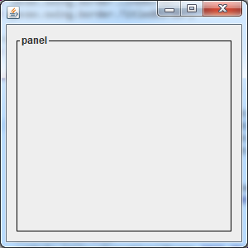The process of creating a GUI inn Swing starts with creating a class (like pawn, players, etc.) that represents the main GUI. An article of this class acts as a container which holds all the other components to be displayed.
* In our project, the main interface article is a frame, i.e., the JFrame class in javax.swing package. A frame is basically a window which is displayed whenever a user opens an application on his/her computer.
* Apart from the title, the size of the frame can also be customized. It can be established by incorporating the setSize(int, int) method by inserting the width and height for the frame. The size of a frame is designated in pixels.

2.1.6 **Libraries:**

* **java.awt**-

Contains all of the classes for creating user interface and for painting graphics and images in Ludo game. Java AWT or Abstract Window Toolkit is an API used for developing GUI.

* **java.swing**-

It is used to develop GUI, desktop-based applications (as the game is desktop based). Swing is built solely in Java and built on top of the AWT.

Swing components are lightweight and more powerful (tables, lists, color choosers, etc.) are made with their help.

It supports a better look (enhances the look of the game) and feel that can plug into anything.

* **java.awt.event**-

Provides interfaces and classes for dealing with different types of events fired by AWT components. Events are fired by event sources.

An event listener registers with an event source to receive notifications about the events of a particular type.

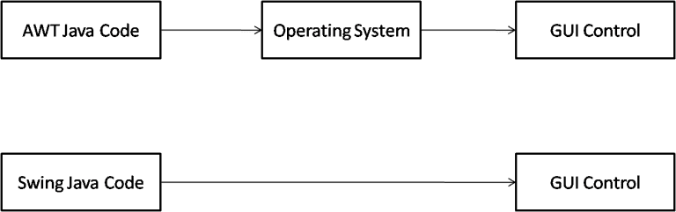This package defines events and event listeners, as well as event listener adapters, which are convenient classes to make easier the process of writing event listeners.

2.2 **FLOWCHART OF JFRAME HIERARCHY**

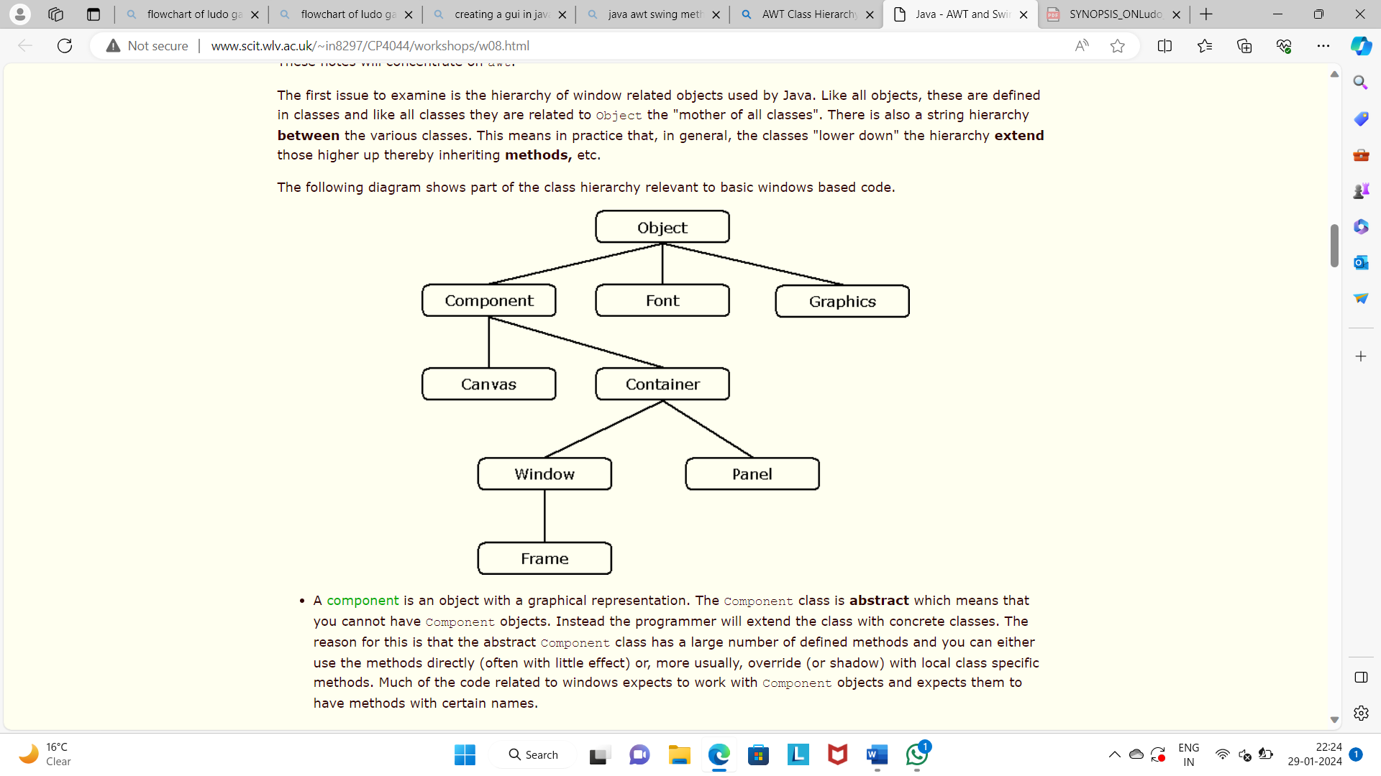

2.3 **FLOWCHART OF GAME’S WORKING**

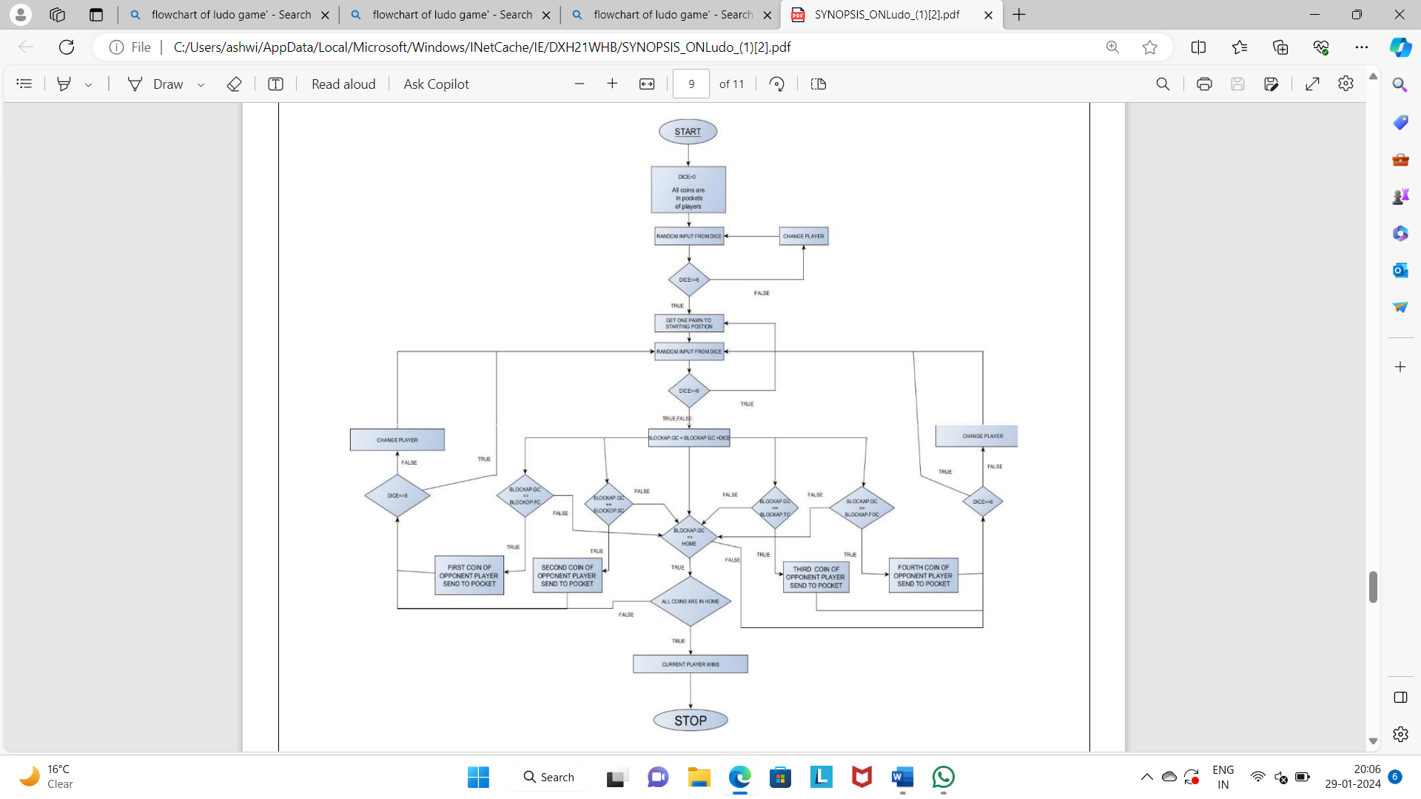

**CHAPTER 3**

**IMPLEMENTATION**

3.1 **Importing Libraries**

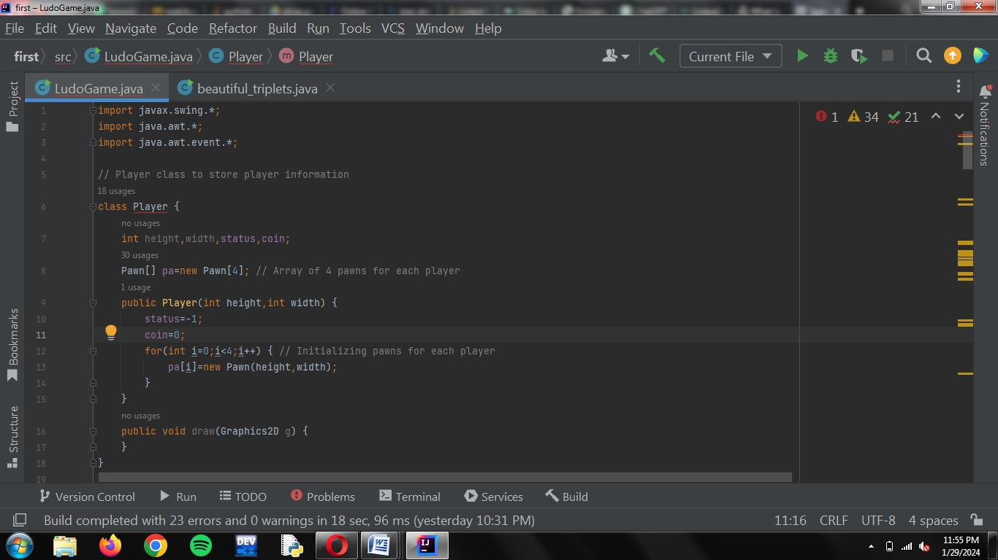

3.2 **Introducing class to store player’s information**

3.3 **Storing Pawn’s Information**

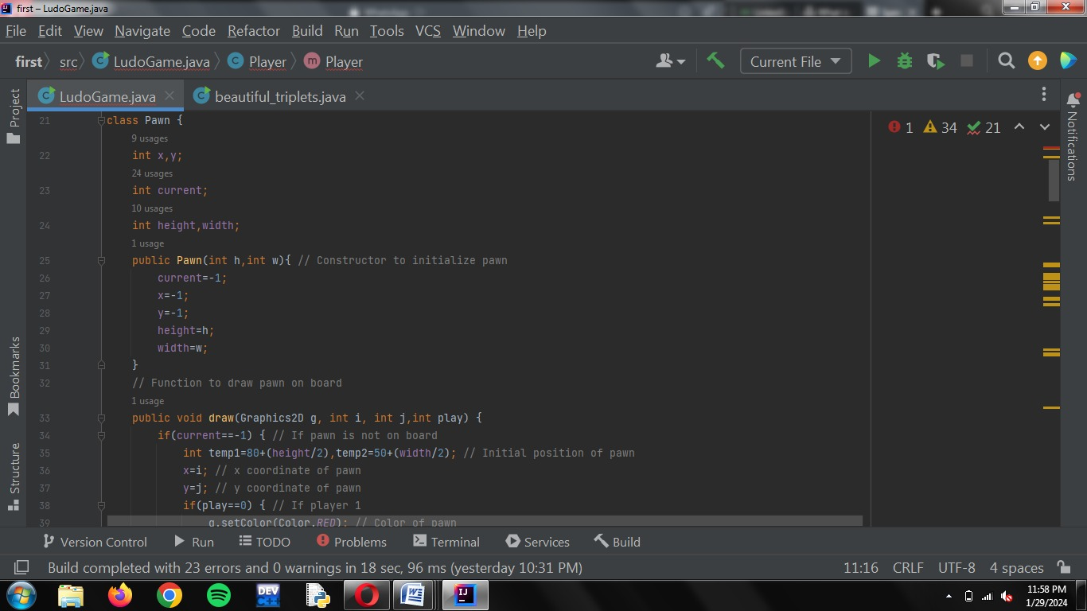

3.4 **Drawing Pawn on Board**

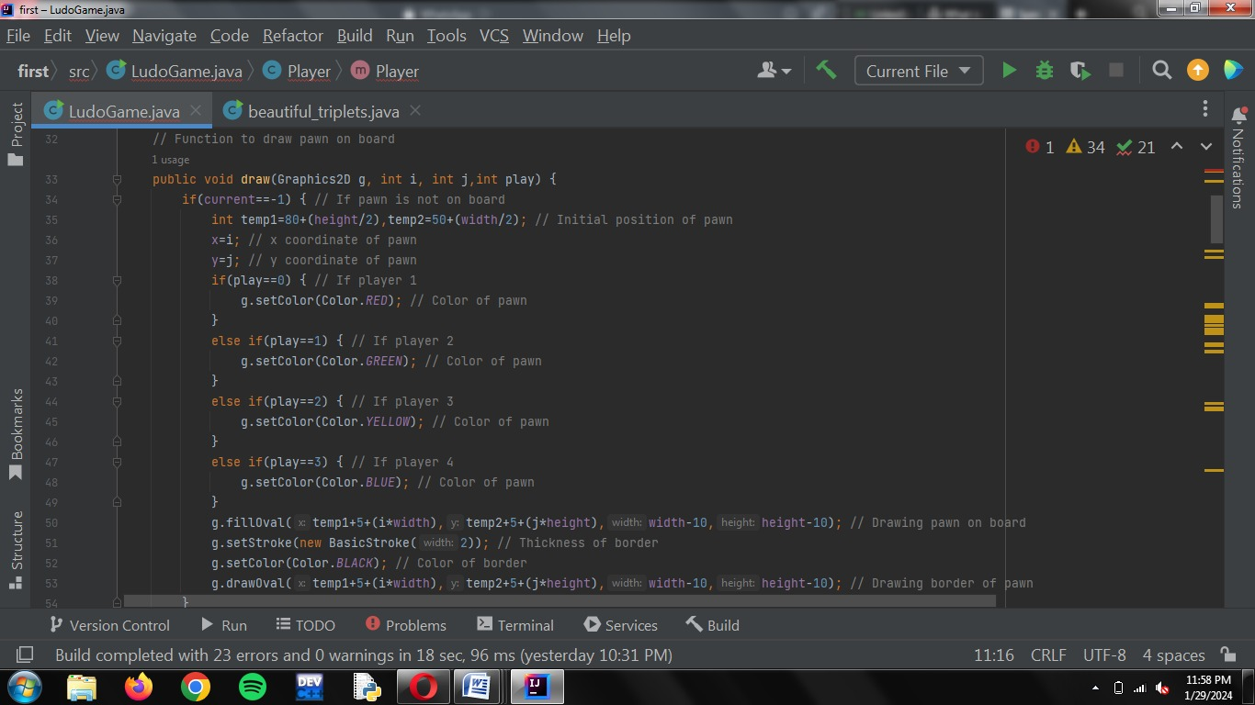

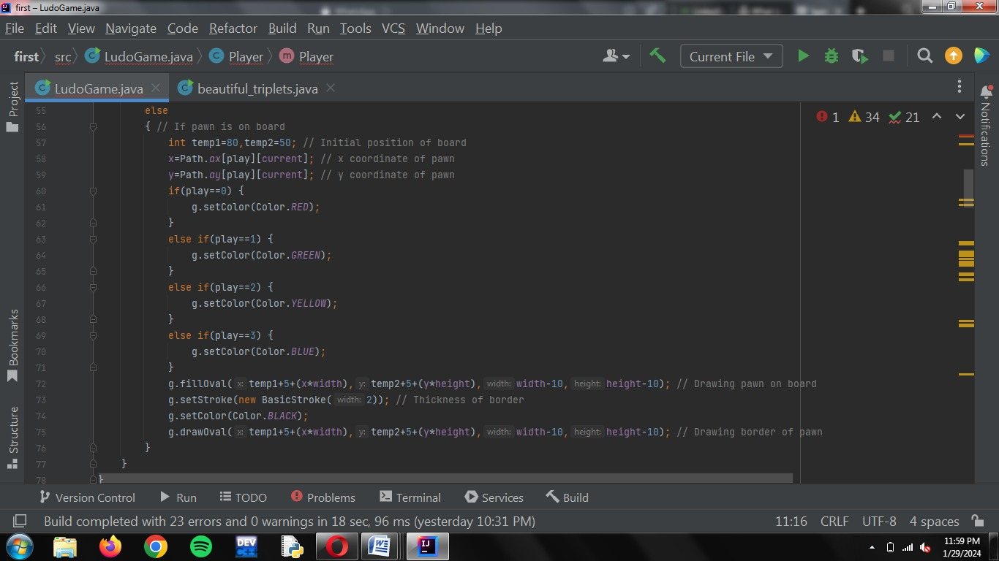

3.5 **Creating Path**

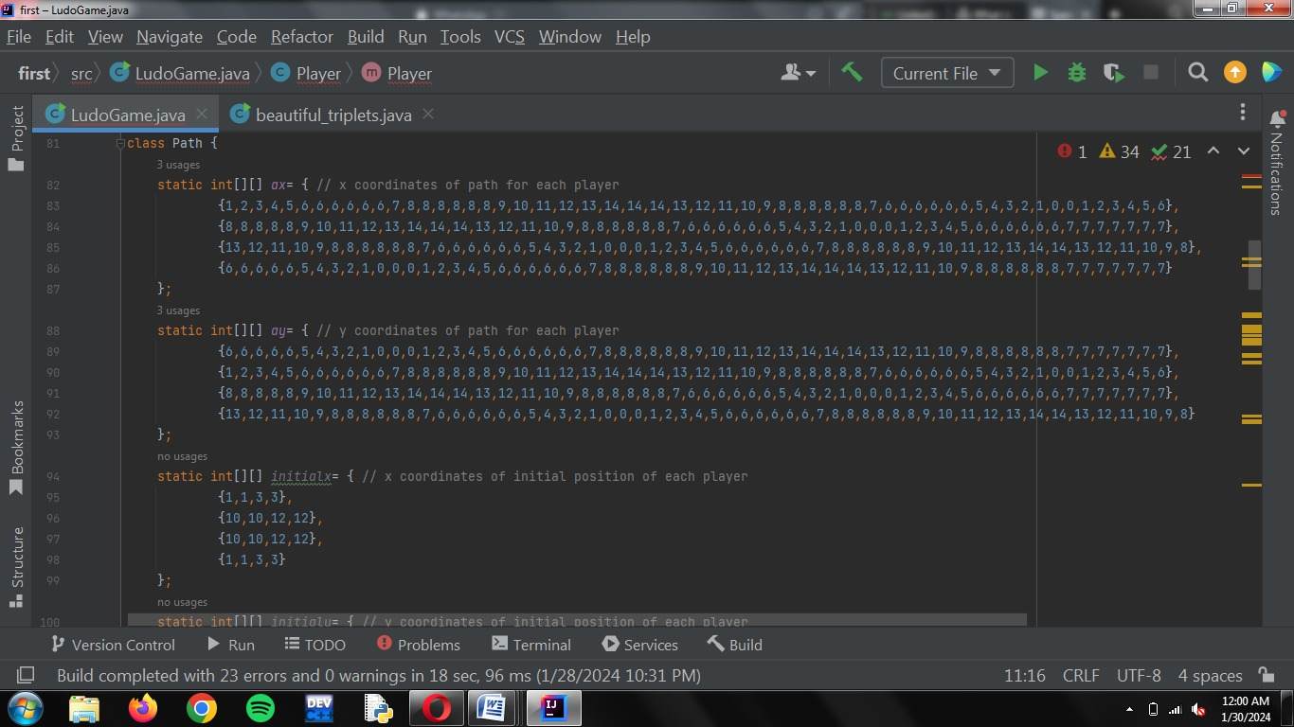

3.6 **Creating Layout**

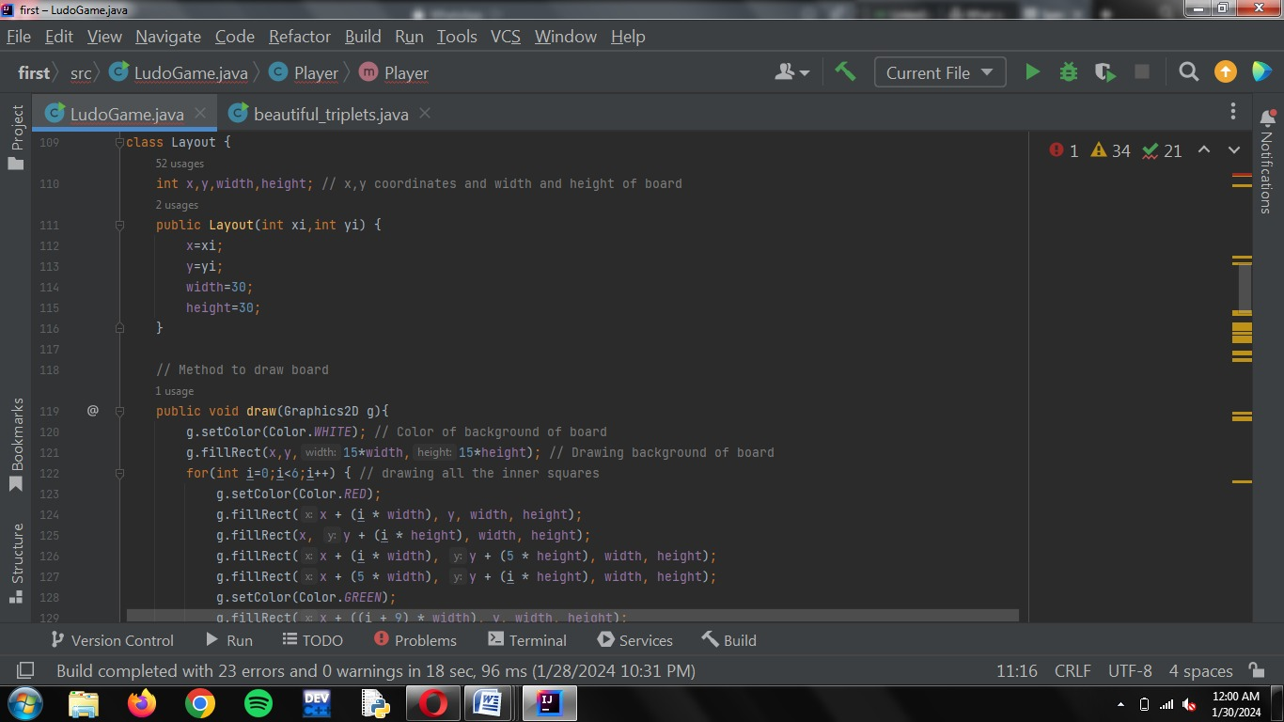

3.7 **Method to draw Board**



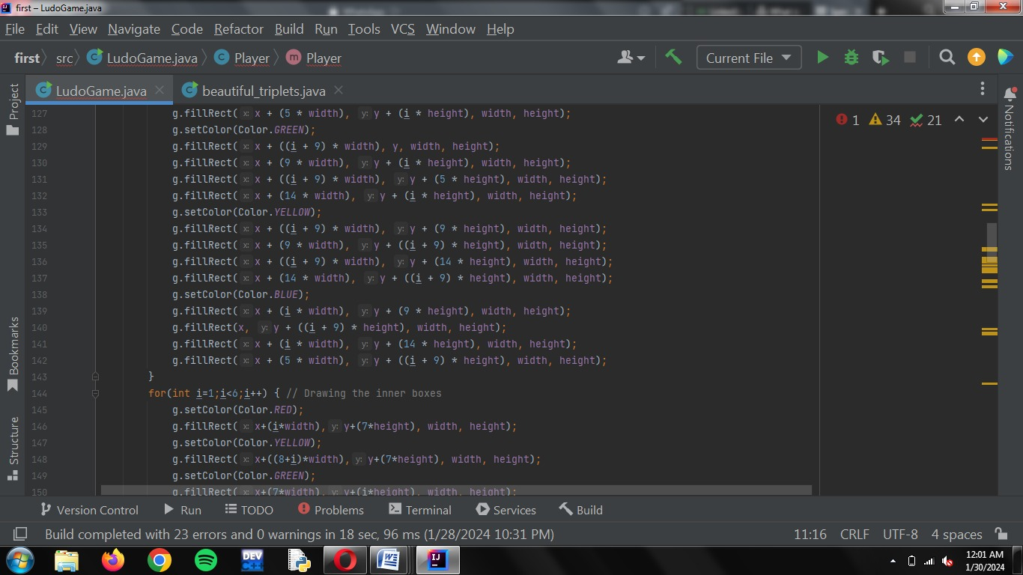

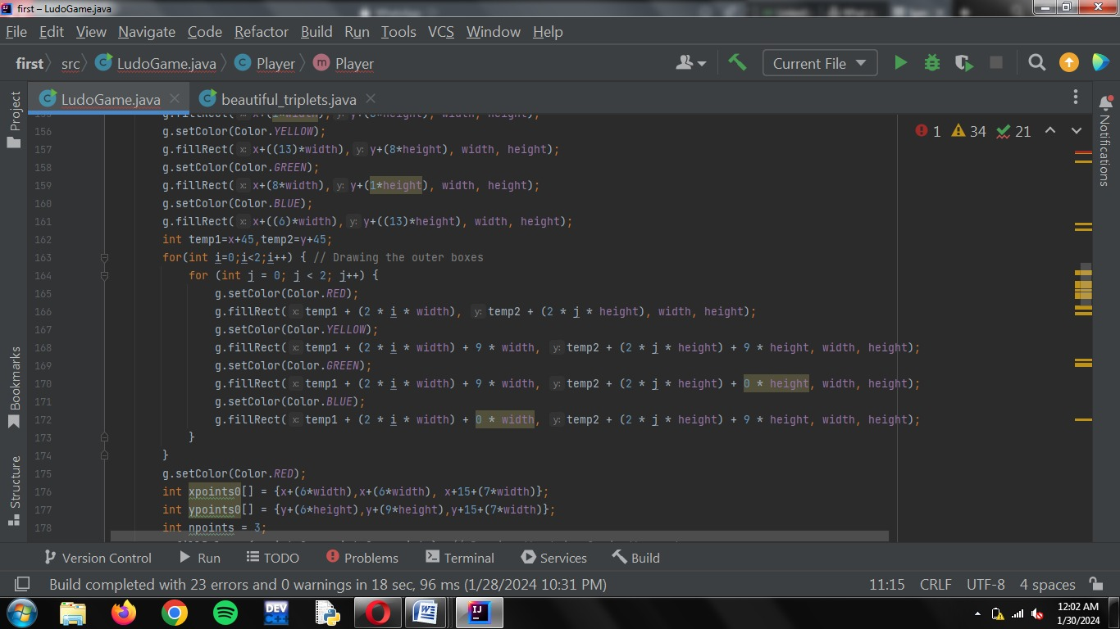

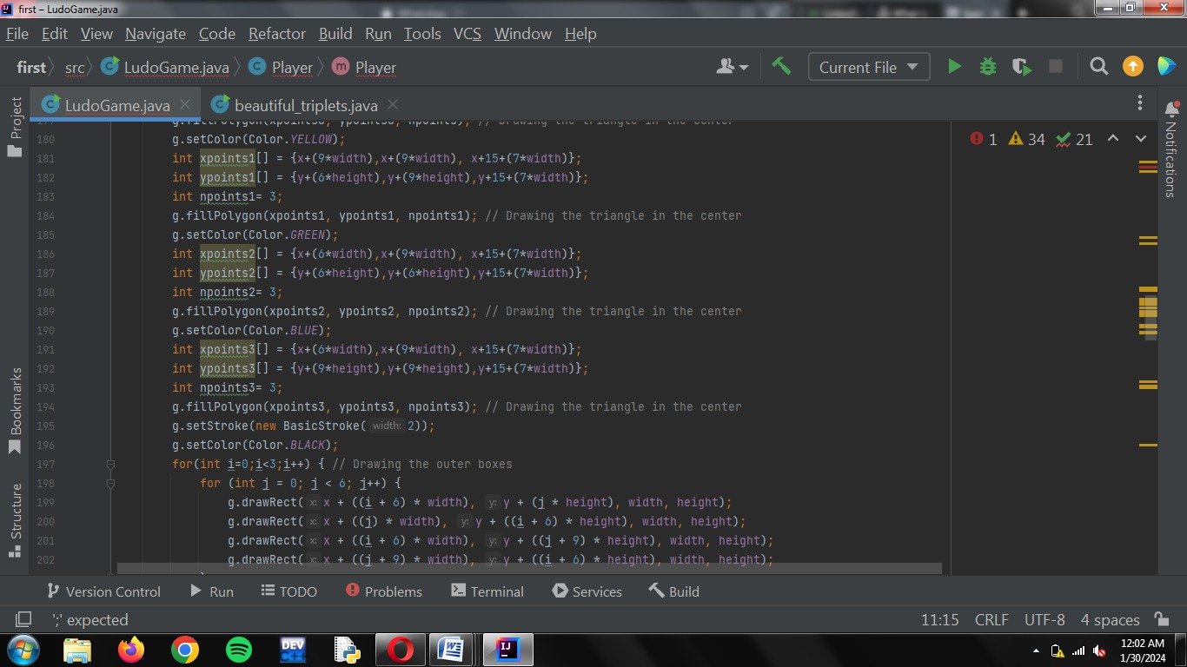

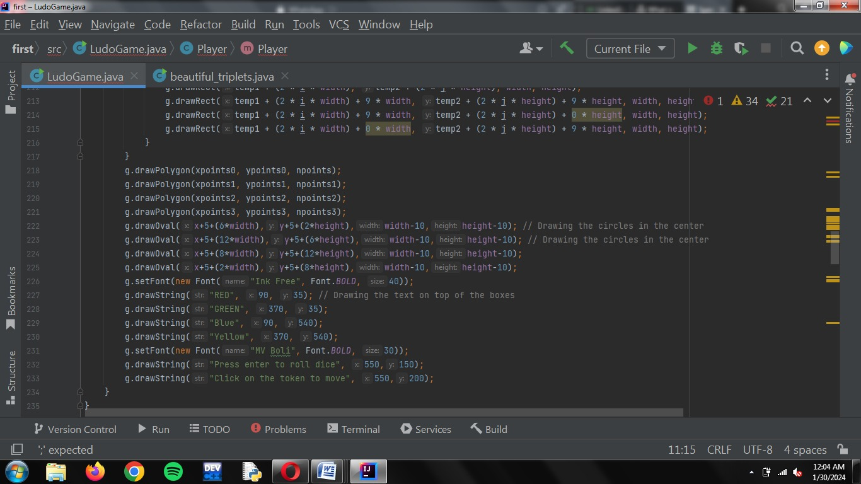

3.8 **Initializing the player’s positions**

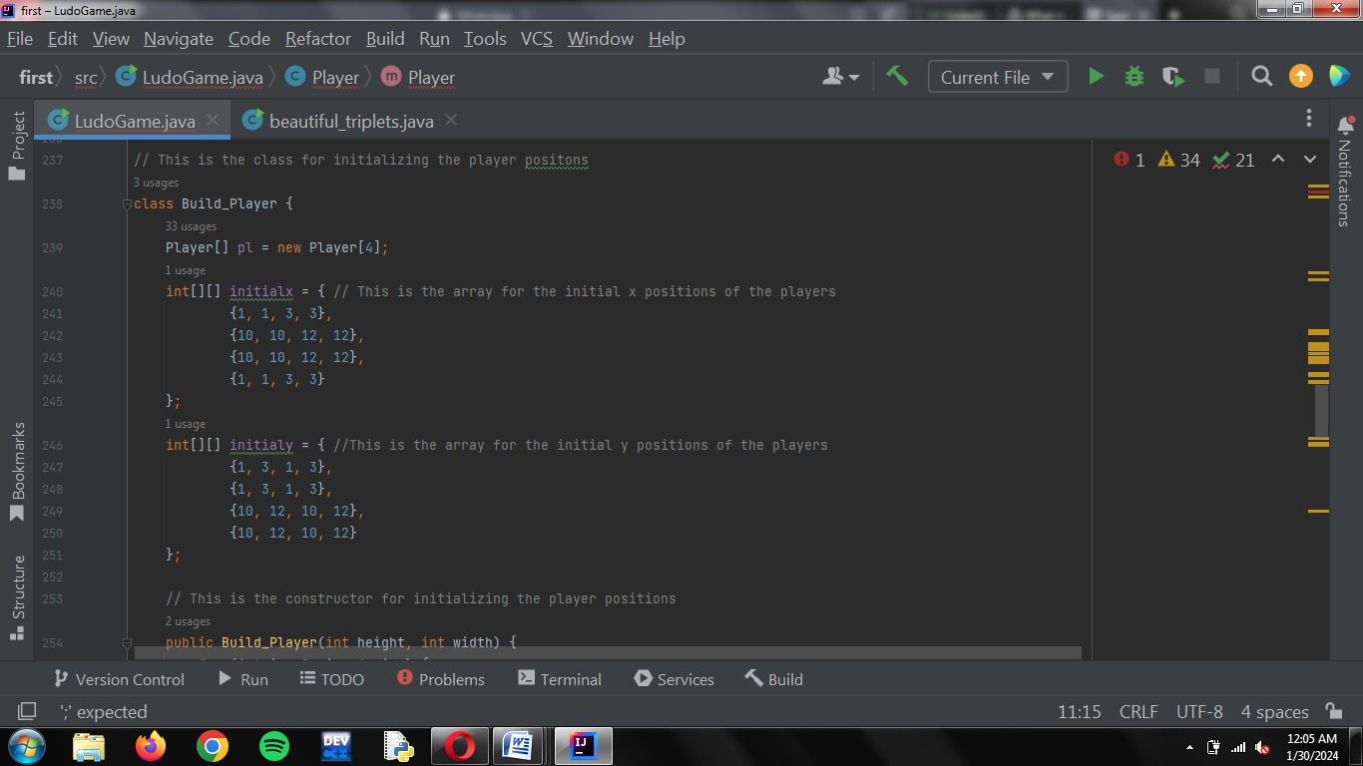

3.9 **Class for Game’s move**

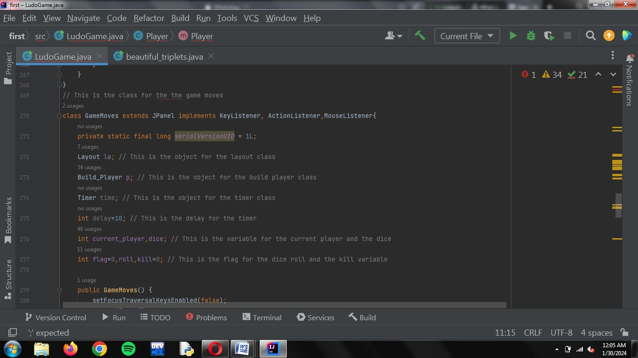

3.10 **Method for drawing the game**

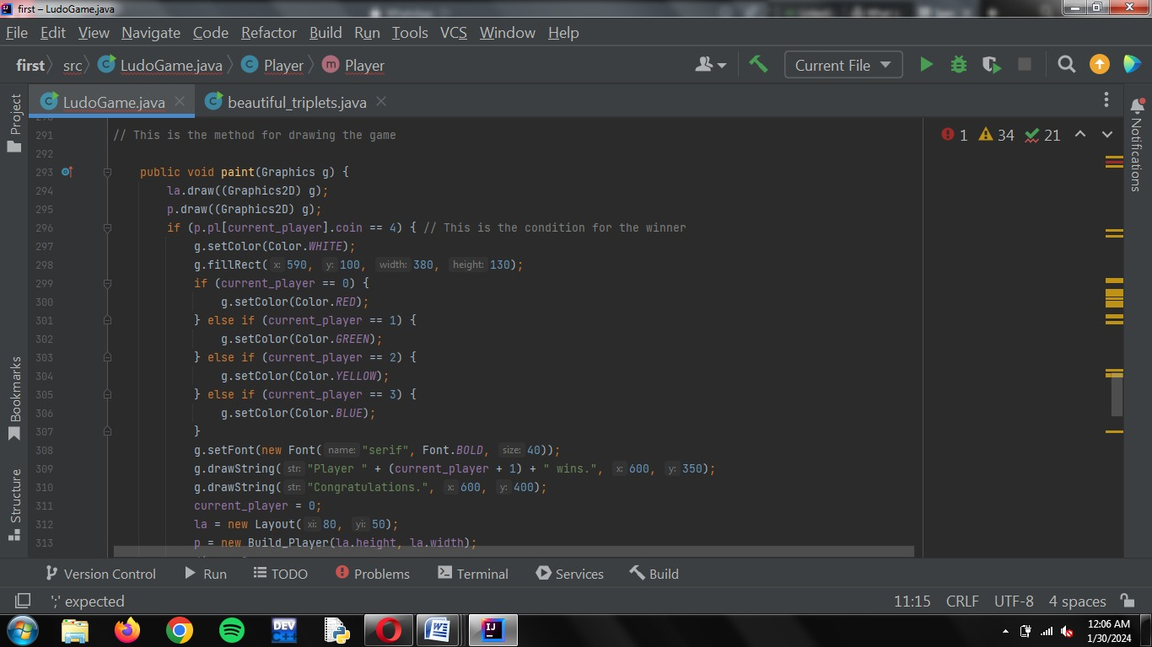

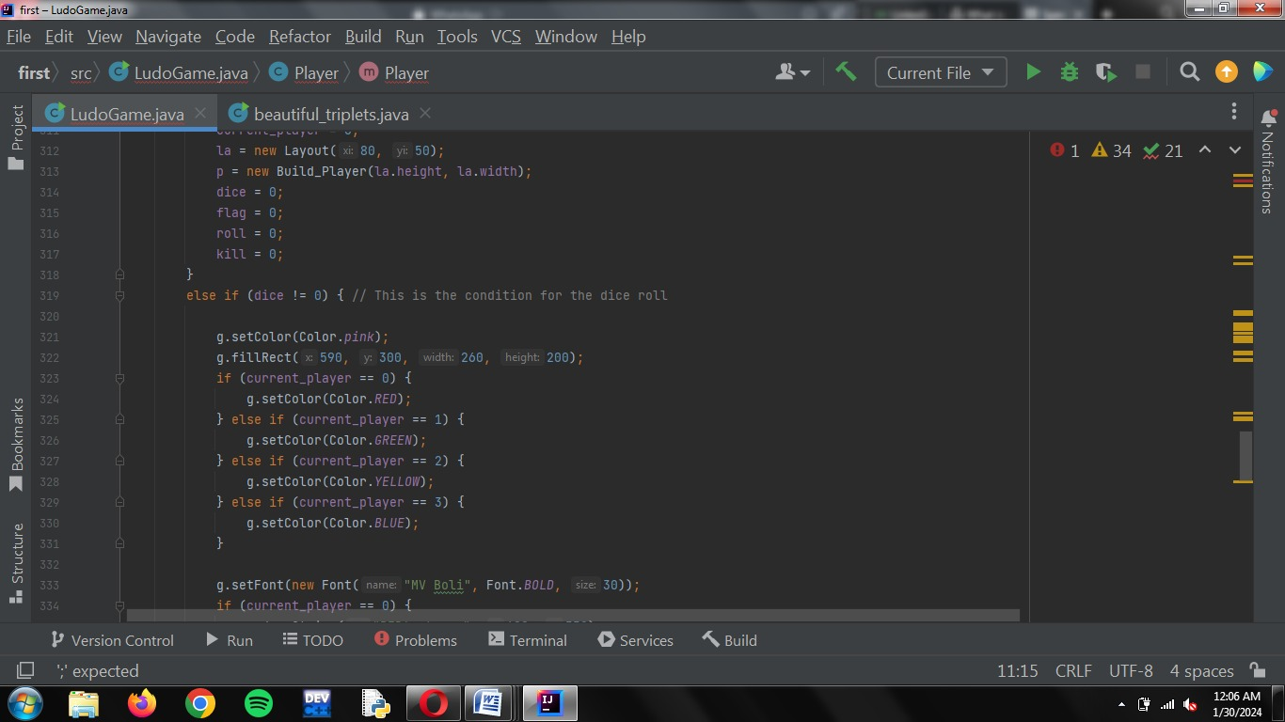

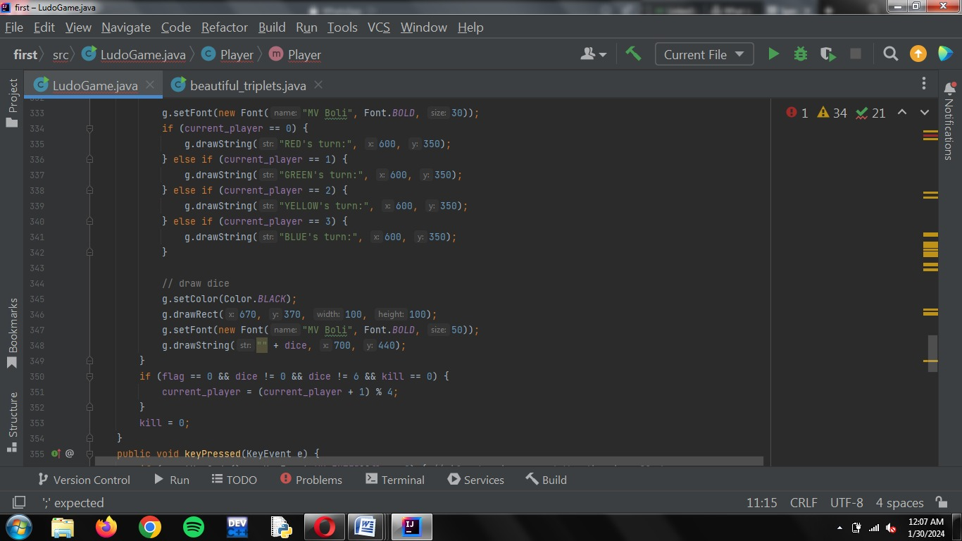

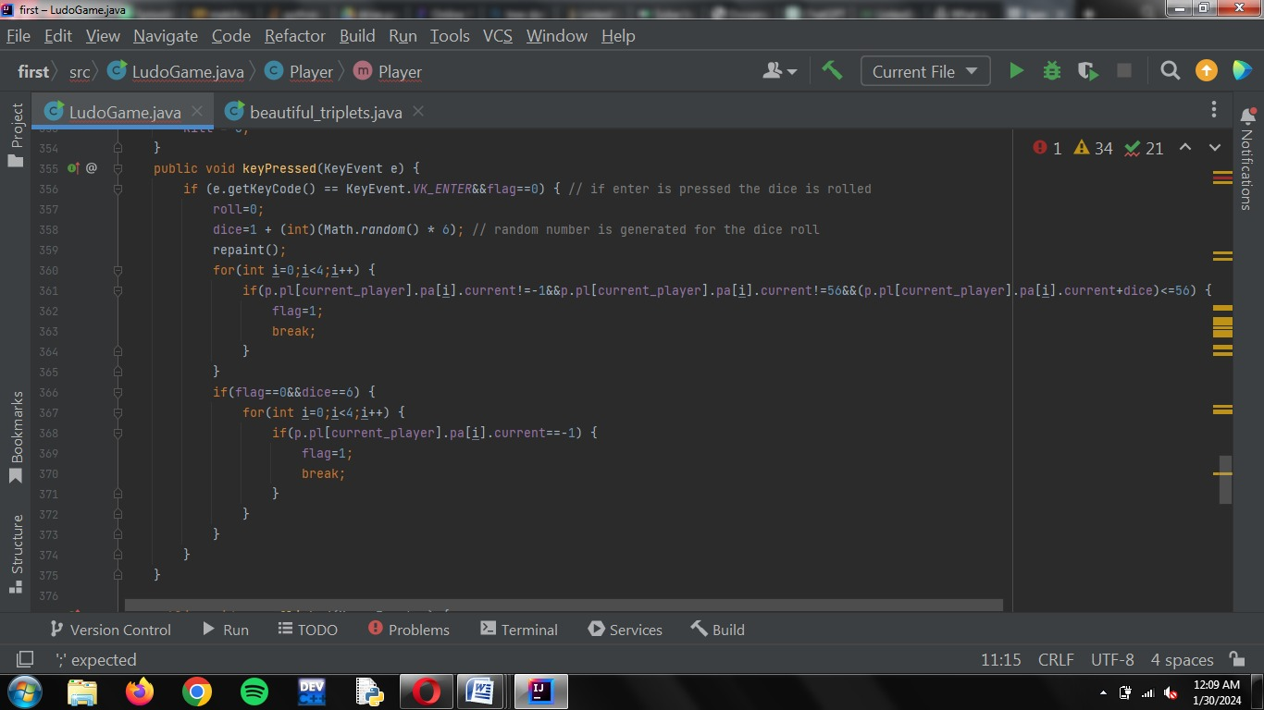

3.11 **Taking User Input through mouse and keys**

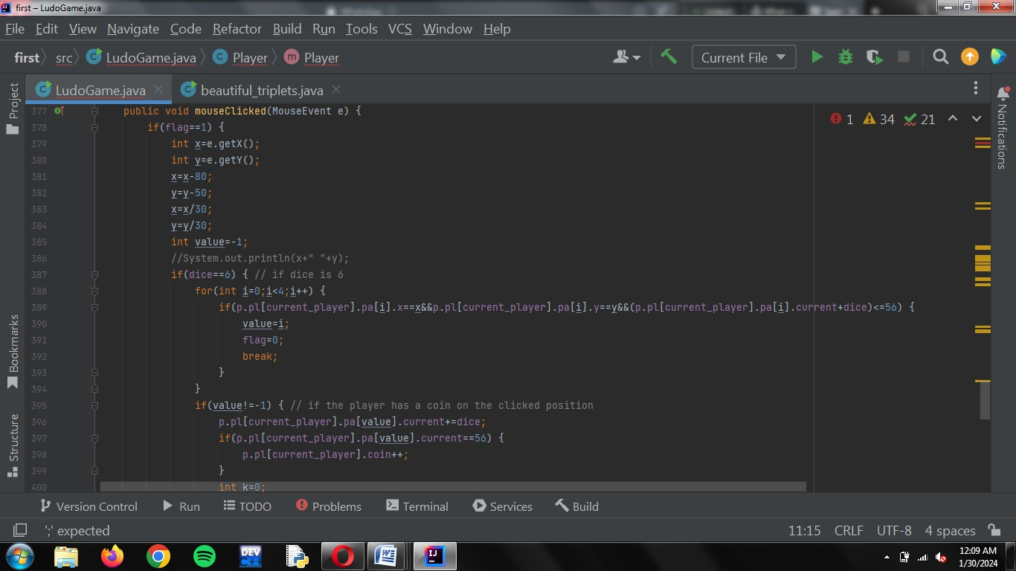

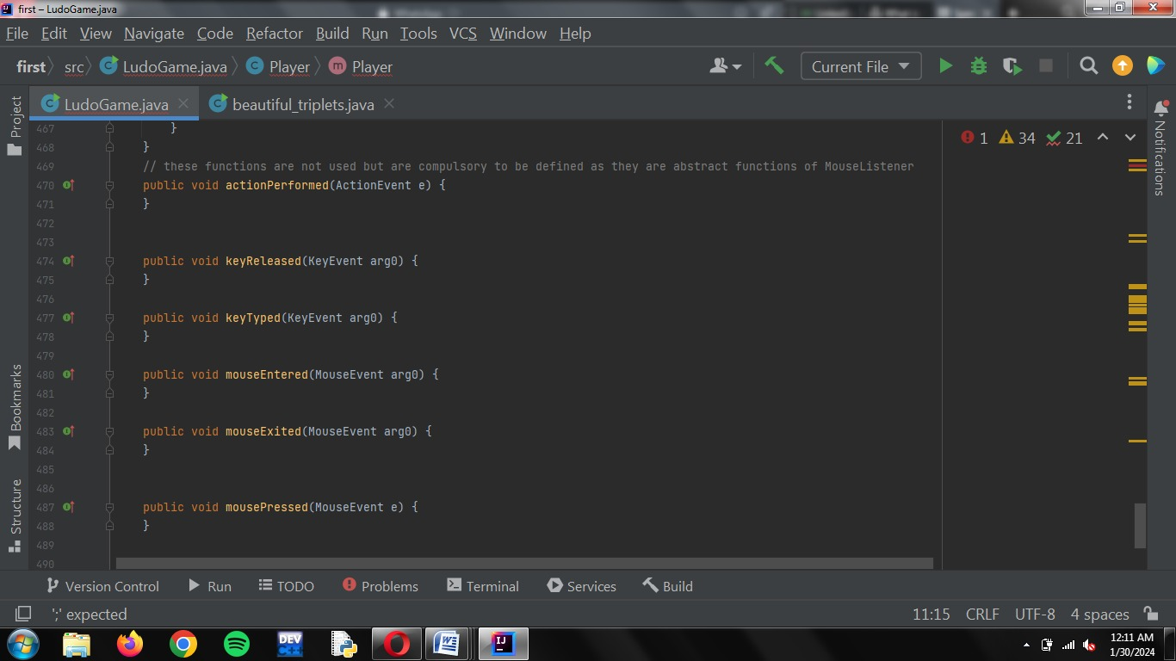

3.12 **Game Screen MAIN Function**

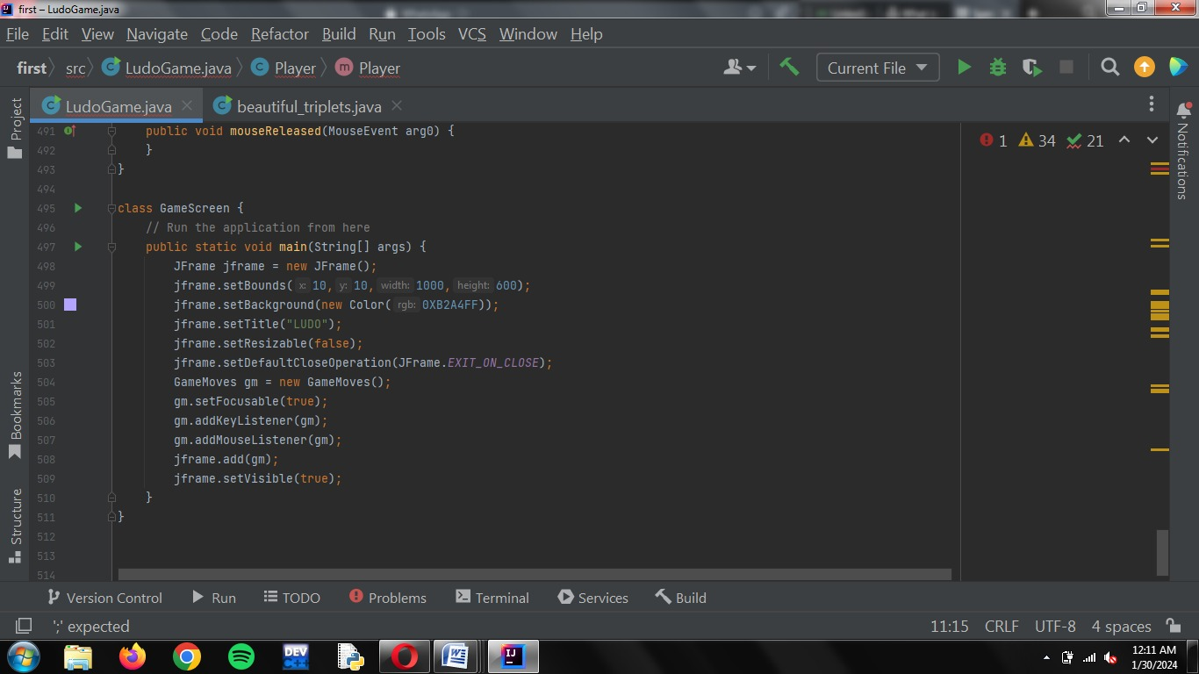

3.13 **Outcome**

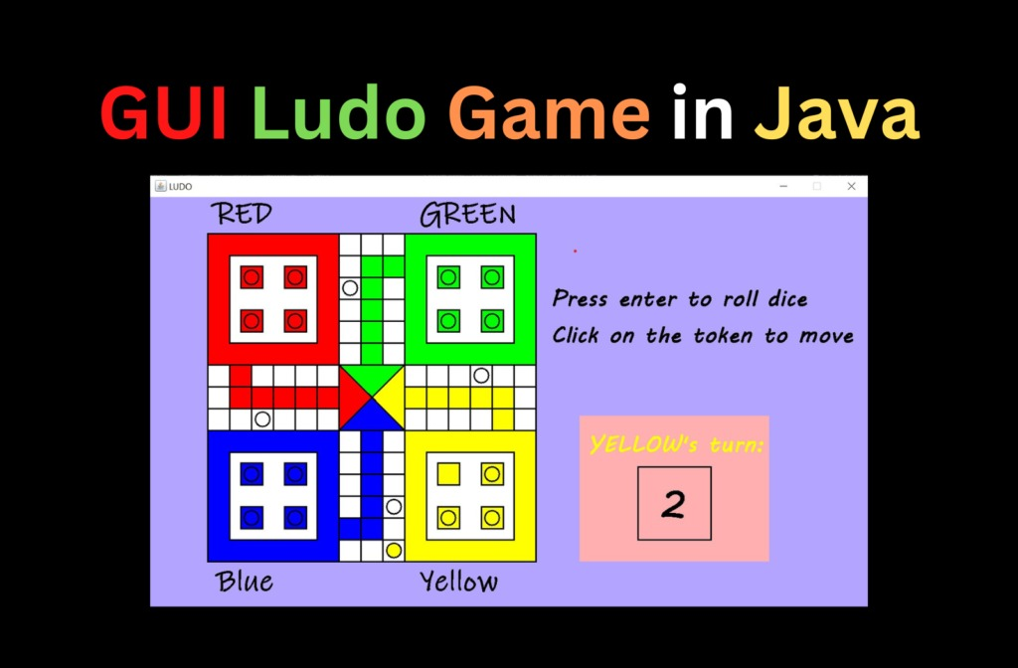

**CHAPTER 4**

**TESTING/RESULT AND ANALYSIS**

Testing a window-based Ludo game involves assessing different aspects such as functionality, user interface, gameplay mechanics, and overall user experience. Below are key areas to focus on during testing, along with possible results and analysis:

4.1 **Functionality Testing:**

* + **Expected Results:**
    - Dice rolling mechanism works correctly.
    - Tokens move according to the rules of the game.
    - Winning conditions are properly identified.
    - Multiplayer support allows multiple players to interact.
  + **Analysis:**
    - Verify that all game mechanics align with Ludo rules.
    - Ensure tokens move the correct number of spaces based on the dice roll.
    - Confirm that the game correctly identifies and announces winners.
    - Test multiplayer functionality to ensure smooth interaction.

4.2 **User Interface Testing:**

* + **Expected Results:**
    - Graphical elements are visually appealing.
    - User interactions are intuitive.
    - Clear instructions and prompts for players.
  + **Analysis:**
    - Evaluate the visual design, ensuring it is engaging and user-friendly.
    - Test user interactions, such as rolling the dice and moving tokens, to ensure ease of use.
    - Check for clear instructions and feedback during the game.

4.3 **Error Handling Testing:**

* + **Expected Results:**
    - Graceful handling of unexpected user inputs.
    - Appropriate error messages for invalid moves.
  + **Analysis:**
    - Intentionally provide invalid inputs and assess how the game responds.
    - Check if error messages are informative and guide users.

4.4 **Performance Testing:**

* + **Expected Results:**
    - Smooth gameplay without lags.
    - Responsiveness to user inputs.
  + **Analysis:**
    - Evaluate the game's performance on different devices and screen sizes.
    - Check for any delays or lags during gameplay.
    - Ensure the game responds promptly to user actions.

4.5 **Security Testing:**

* + **Expected Results:**
    - Protection against common vulnerabilities.
    - Secure handling of user data (if applicable).
  + **Analysis:**
    - Assess the code for potential security risks.
    - Verify that the game does not allow unauthorized access or manipulation.
    - If the game involves online multiplayer, ensure secure communication.

4.6 **Cross-browser and Cross-device Testing:**

* + **Expected Results:**
    - Consistent performance and appearance across different browsers and devices.
  + **Analysis:**
    - Test the game on various browsers (Chrome, Firefox, Safari, etc.).
    - Assess how the game adapts to different screen sizes and resolutions.

4.7 **Multiplayer Testing (if applicable):**

* + **Expected Results:**
    - Seamless interaction between multiple players.
    - Synchronization of game state among all players.
  + **Analysis:**
    - Test the multiplayer feature with the intended number of players.
    - Verify that all players see the same game state simultaneously.

4.8 **Scalability Testing:**

* + **Expected Results:**
    - The game should handle an increasing number of users without performance degradation.
  + **Analysis:**
    - Test the game with varying numbers of players to assess its scalability.
    - Ensure that the performance remains acceptable as the number of players increases.

4.9 **User Experience (UX) Testing:**

* + **Expected Results:**
    - Positive and enjoyable gaming experience.
    - Intuitive controls and navigation.
  + **Analysis:**
    - Collect feedback from users about their overall experience.
    - Address any pain points or areas where users may find the game confusing.

4.10 **Regression Testing:**

* + **Expected Results:**
    - New features and updates should not break existing functionalities.
  + **Analysis:**
    - Re-test existing functionalities after introducing updates or new features.
    - Ensure that any changes do not introduce unexpected issues.

4.11 **Documentation Review:**

* + **Expected Results:**
    - Clear and comprehensive documentation for users and developers.
  + **Analysis:**
    - Review documentation to ensure it provides sufficient information for users to understand and play the game.
    - Developers should find the documentation helpful for maintaining and extending the game.

4.12 **Accessibility Testing:**

* + **Expected Results:**
    - The game is accessible to users with disabilities.
  + **Analysis:**
    - Verify that the game complies with accessibility standards.
    - Test with accessibility tools and assess if users with disabilities can interact with the game effectively.

Testing the Ludo game thoroughly in these areas will help ensure a robust and enjoyable gaming experience for users. Analysing the results from each testing category will guide improvements and optimizations to make the game more polished and user-friendly.

Top of Form

**CHAPTER 5**

**CONCLUSION AND FUTURE ENHANCEMENTS**

5.1 **Conclusion**

The window-based Ludo game has undergone comprehensive testing in various aspects, including functionality, user interface, error handling, performance, security, cross-browser compatibility, multiplayer support, scalability, user experience, regression, documentation, and accessibility. The results of the testing process provide valuable insights into the game's strengths and areas for improvement.

5.1.1 **Positive Aspects:**

* + The core functionalities of the game, such as dice rolling, token movement, and win conditions, work as expected.
  + The user interface is visually appealing and intuitive, providing a positive gaming experience.
  + Error handling is effective, with appropriate messages guiding users in case of invalid inputs.
  + The game demonstrates smooth performance and responsiveness, offering an enjoyable gameplay experience.
  + Security measures have been considered, protecting against common vulnerabilities.

5.1.2 **Areas of Improvements:**

* **Multiplayer Interaction-** Further testing and optimization may be needed to ensure seamless interaction between multiple players, especially in an online multiplayer setting.
* **Scalability-** Evaluate the game’s performance with a larger number of players to ensure scalability without degradation in user experience.
* **Documentation-** Enhance documentation to provide more comprehensive guidance for users and developers.
* **Accessibility-** Continue refining accessibility features to ensure the game is inclusive and accessible to user with disabilities.

5.2 **Future Enhancements**

* **Enhanced Multiplayer Features:**

Implement additional features to enhance the multiplayer experience, such as chat functionalities, leaderboards, and the ability to create private game rooms.

* **Customization Options:**

Allow players to customize their gaming experience, such as choosing different board layouts, themes, or token designs.

* **AI Opponents:**

Integrate artificial intelligence opponents for single-player mode, providing a challenging experience for users playing solo.

* **Tournaments and Challenges:**

Introduce tournament modes and challenges to add a competitive elements to the game, encouraging players to compete against each other.

* **Social Integration:**

Implement social media integration to allow players to share their achievements, high scores, and game progress with their friends.

* **Cross-Platform Support:**

Develop versions of the game for different platforms (mobile, tablet, etc.) to reach a broader audience.

* **Power-ups and Special Moves:**

Introduce power-ups or special moves that players can acquire during the game, adding strategic elements to the gameplay.

* **Dynamic Board Environments:**

Experiment with dynamic board environments, introducing obstacles or changing layouts during gameplay to keep it engaging.

* **Analytics and User Feedback:**

Implement analytics to gather data on user behavior and preferences, and actively seek and incorporate user feedback for continuous improvement.

* **Expand Accessibility Features:**

Continue refining accessibility features based on user feedback and in compliance with evolving accessibility standards.

* **Localization:**

Offer the game in multiple languages to cater to a global audience, considering cultural preferences in design and gameplay.

* **Extended Documentation:**

Provide more in-depth documentation for developers, facilitating easier maintenance, updates, and customization.

By addressing these areas for improvement and implementing future enhancements, the window-based Ludo game can evolve into a more feature-rich, inclusive, and engaging experience for players. Regular updates and community engagement will contribute to the sustained success and popularity of the game.

**REFERENCES [IEEE FORMAT]**

* Google Scholar (<https://scholar.google.com/>)
* Wikipedia (<https://www.wikipedia.org/>)
* Oracle Corporation, “Java SE Documentation,” Oracle, [Online], Available: (<https://docs.oracle.com/en/java/javase/index.html>)
* T. Smith, “Java Game Development: Introduction to Game Development,” GameDev.net, 20-Jun-2019, [Online], Available: (<https://www.gamedev.net/articles/programming/general-and-gameplay-programming/introduction-to-game-development-r5237/>)